Expressions with faire

faire du shopping to go shopping
faire des achats to go shopping
faire la vaiselle to do the dishes
faire le ménage to do housework
faire la fête
faire le jardin to work in the yard
faire le lit to make the bed
faire la cuisine to cook
faire la grasse matinée to sleep late
faire les devoirs to do homework
faire des photos to take pictures
faire les bagages to pack
faire la bise to kiss hello
faire les bêtises to act silly, foolish
faire la tête to pout, sulk
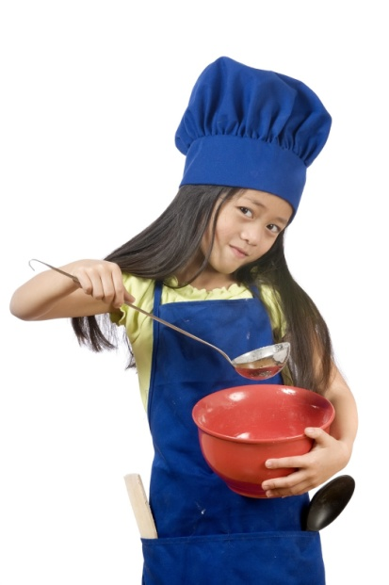
faire du lard to sit around doing nothing
(like a couch potato)
And don’t forget expressions about the weather:
Il fait _____________ beau/bon/chaud/froid/frais
etc...

