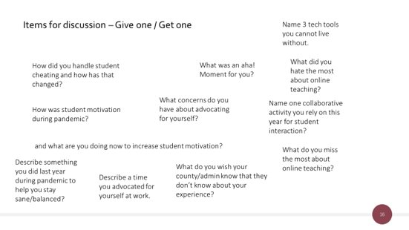
How did you handle student cheating during virtual school? How has that changed this year? | What was an “aha!” moment for you during the pandemic or this year? | Name 3 tech tools you CANNOT live without.
How was student motivation for you during pandemic? Is it different now? | What concerns to you have about advocating for yourself? | What do/did you hate most about online teaching?
Name one collaborative activity you rely on this year for student interaction? | What do you miss most about online teaching? | What are you doing now to increase student motivation?
Paper or Paperless? Why? | Describe something you did last year during the pandemic to help you stay sane/balanced? | Describe a time you advocated for yourself at work.
What do you wish your county/administration knew that they don’t know about your experience? | What podcasts are you listening too? (Education or otherwise) | What FB groups do you belong to (education-related)?
How have your planning strategies changed over the past 2 years? | What’s a good strategy you use to scaffold reading/listening? | What’s a good strategy you use to scaffold writing/speaking?
Talk about your PLC experience at school? Valuable? Why? | How do you seek collaboration outside your school? | How would you describe your “self-care” strategies today?
How do you talk about ACTFL proficiency guidelines with your students? | Where do you see yourself in 5 years? Why? | How have your classroom management strategies changed in the past two years?
What is something you want to change for NEXT year? | Are there special events you missed with your students during the pandemic that you’ve started again? Why or why not? | What is your biggest challenge this year in your class?
What was your biggest challenge during the pandemic?

